# 

**CURRICULUM VITAE**

**NAME AND SIR NAME** : OKOMO CALVIX OYIER

**ADDRESS** : P.O. BOX. 43-40307,

MAGUNGA

**PERSONAL DATA**

**Nationality :** Kenyan

**Language :** English, Kiswahili,

Dholuo

**Sex :** Male

**Marital status :** Single

**Date of Birth :** 3rd October, 2001

**Place of birth :** KARUNGU

**EDUCATION BACKGROUND**

* **2022- Date:**

MASINDE MULIRO UNIVERSITY OF SCIENCE AND TECHNOLOGY:

Bachelor of Science in Information System and Knowledge Management.

* **2017-2021:**

Studied at B.L TEZZA COMPLEX SECONDARY SCHOOL

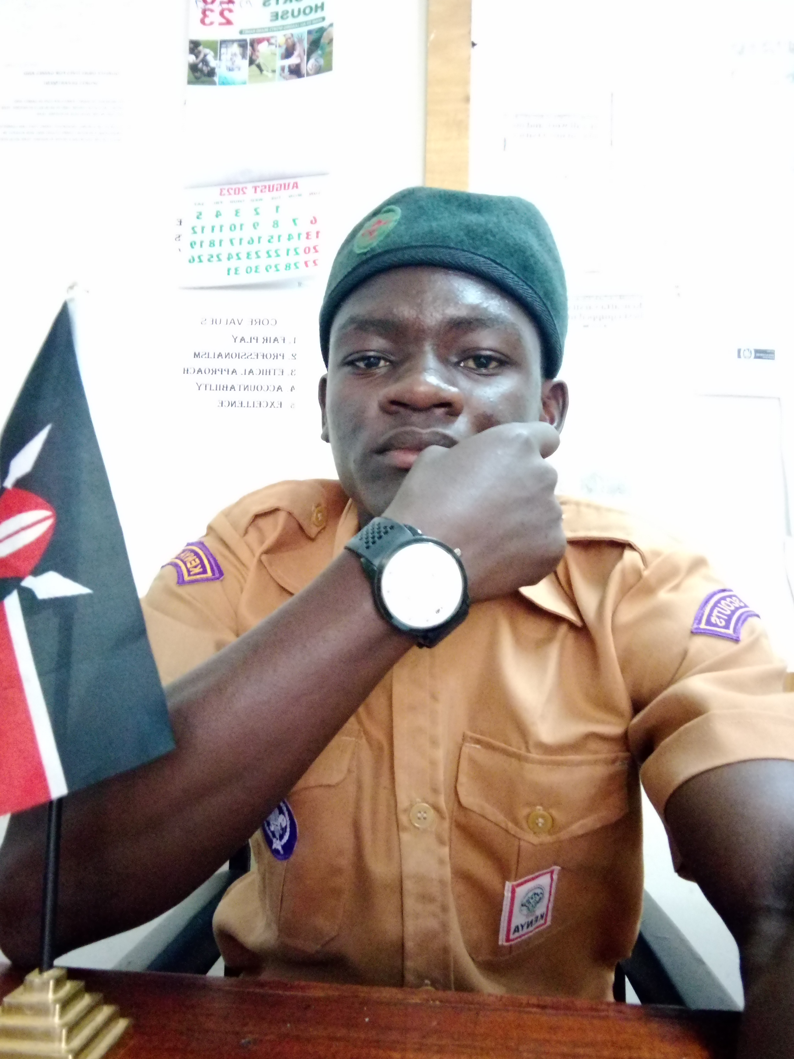

**TELL:** +254713491049/ +254102949050

***E-MAIL*:** [okomocalvix@gmail.com](mailto:okomocalvix@gmail.com)

* **2014-2016:**

Studied at SOKONI PRIMARY SCHOOL.

* **2006-2013:**

Studied at OUR LADY OF MERCY ORORE MARIST BROTHERS

**ADDITIONAL TRAINING**

* **21st to 23rd NOVEMBER 2023:**

Did mental health workshop Training at Masinde Muliro University of Science and Technology.

* **24th FEBRUARY 2023:**

Did and completed an Inter-Preliminary Training Course (ITC) at Kakunga primary school in Kakamega County.

* **16th to 19th MARCH 2023:**

Did and completed a Preliminary Training Course (PTC) at Matende Primary School, Kakamega County.

* **17TH TO 20TH NOVEMBER 2022.**

Did a Dialogue for Peace (DFP) training held at Masinde Muliro University of Science and Technology.

**WORK EXPERIENCE**

* **2024-2025:**

Kenya Scouts Association Masinde Muliro University of Science and Technology Chapter {Eagles Crew}.

* **28th March to 1st March2024:**

16th Edition National Playoffs Kenya Universities Sports Federation (KUSF) Secretariat.

* **2022- 2023:**

Served as Kenya Scout Association Secretary Masinde Muliro University Of Science And Technology Chapter {Eagles Crew}.

* **2018-2021:**

Served as a Scout P.L. God Oloo Secondary School.

* **2015- 2016:**

Served as the Deputy President, Sokoni Primary School.

* **2014- 2015:**

Leader Language Ambassador, Sokoni Primary School.

**Other skills obtained**

* In relation to my degree trajectory, I am an eloquent web developer, who is hipping to android development.
* I am well equipped in matters designing (This implies both web and poster and fliers).

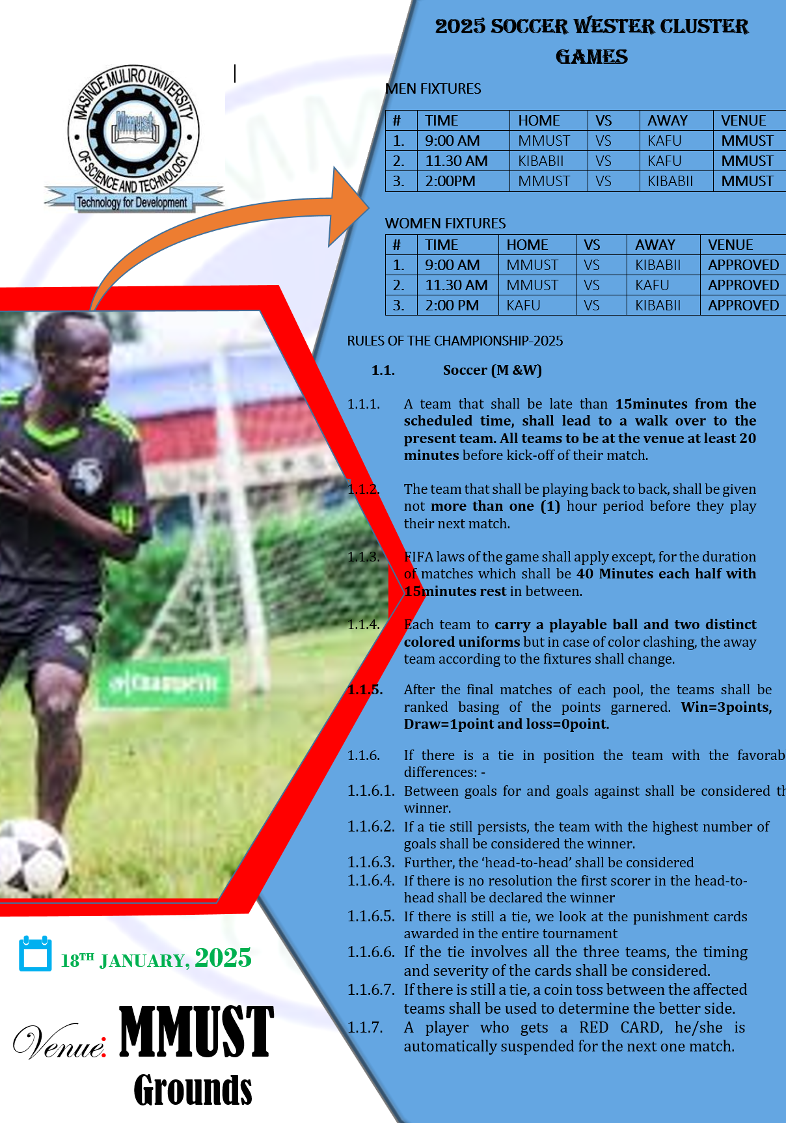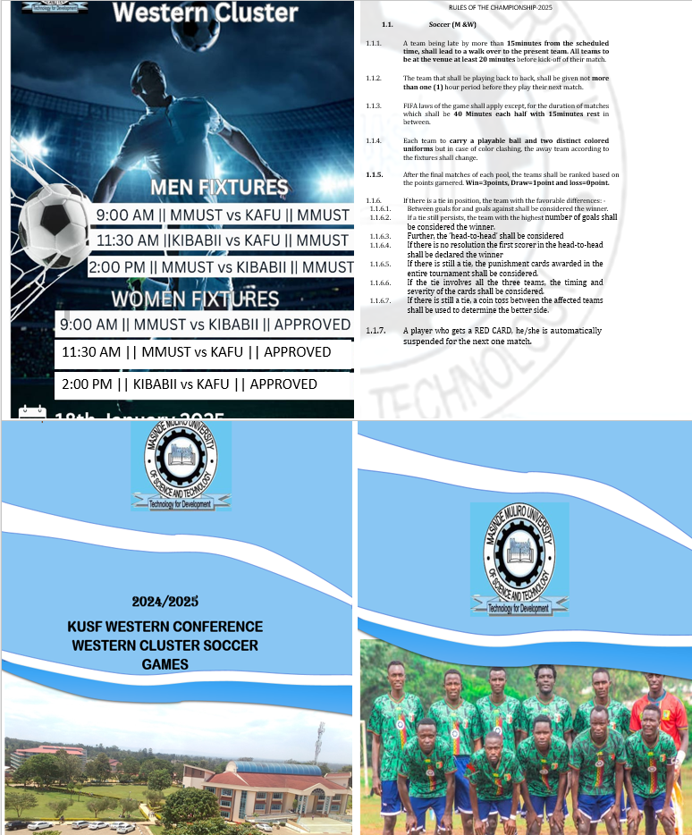

* With the profound leadership experience gathered, I am proud to one of the core founders of Kenya Sign Language Masinde Muliro University of Science And Technology as a club.

REFERENCE

